***Manfred Cabintoy***

***Software Development 1***

***CMPT 220***

***SID: 20078599***

Java VM version / Java Compiler version

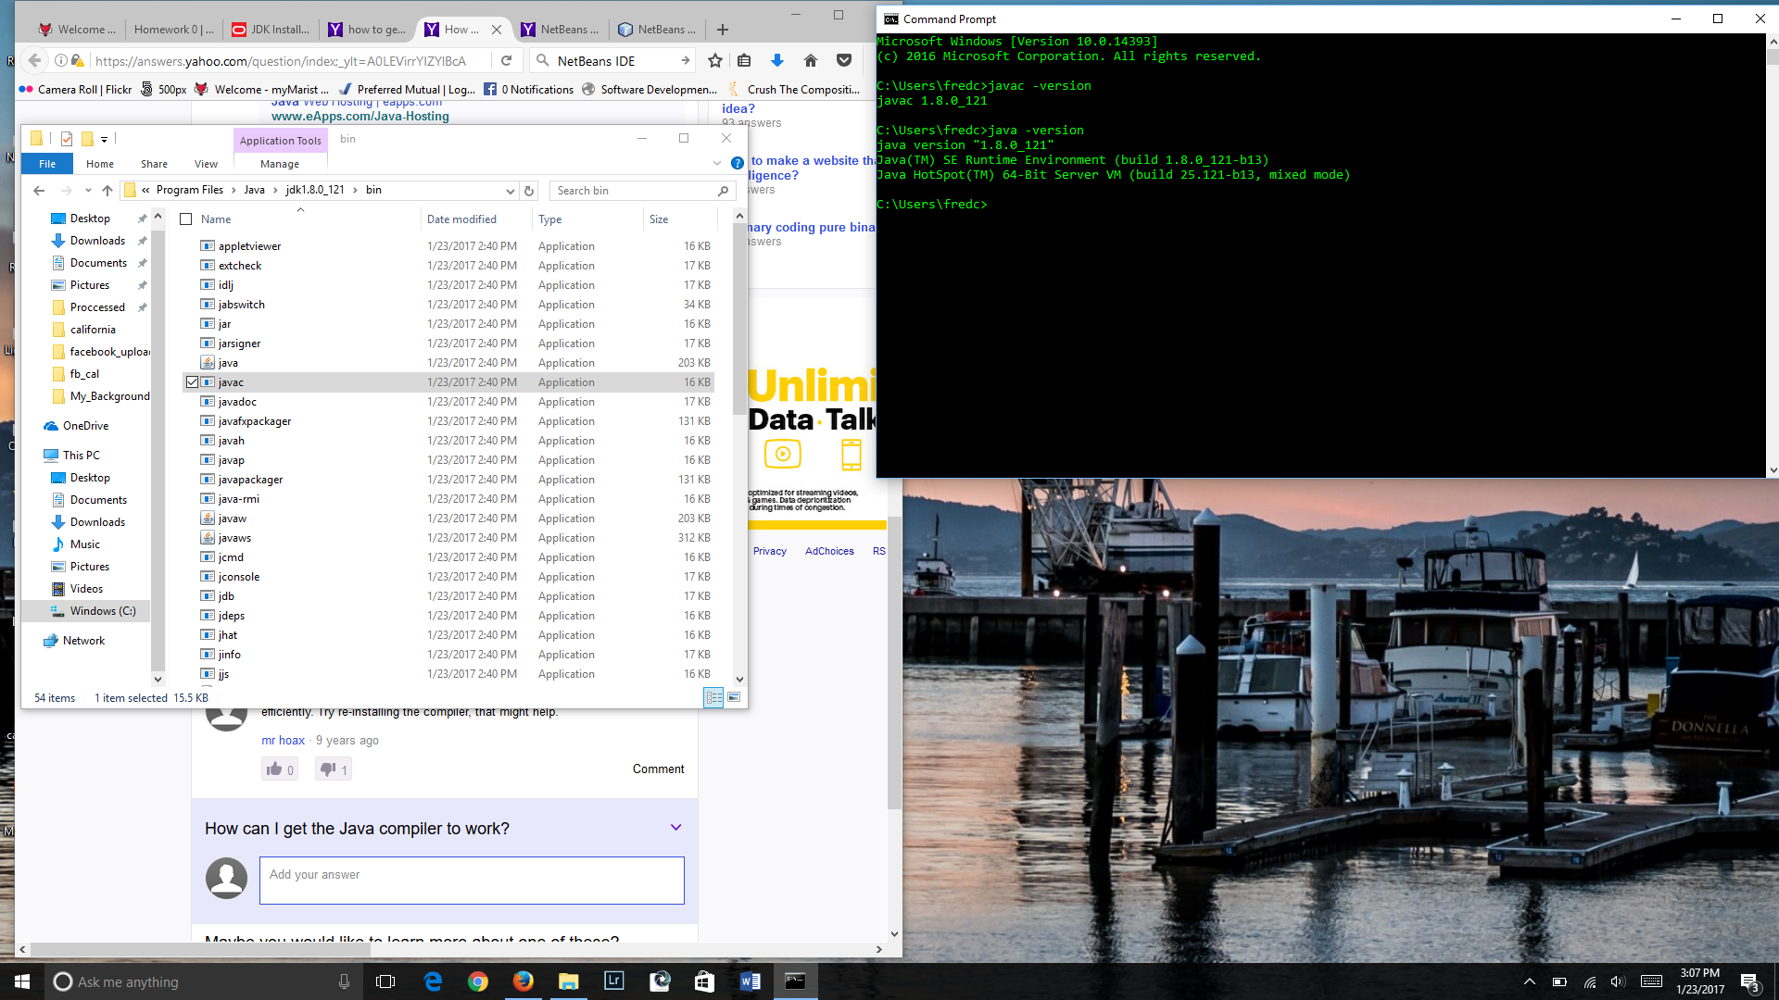

Kattis Account

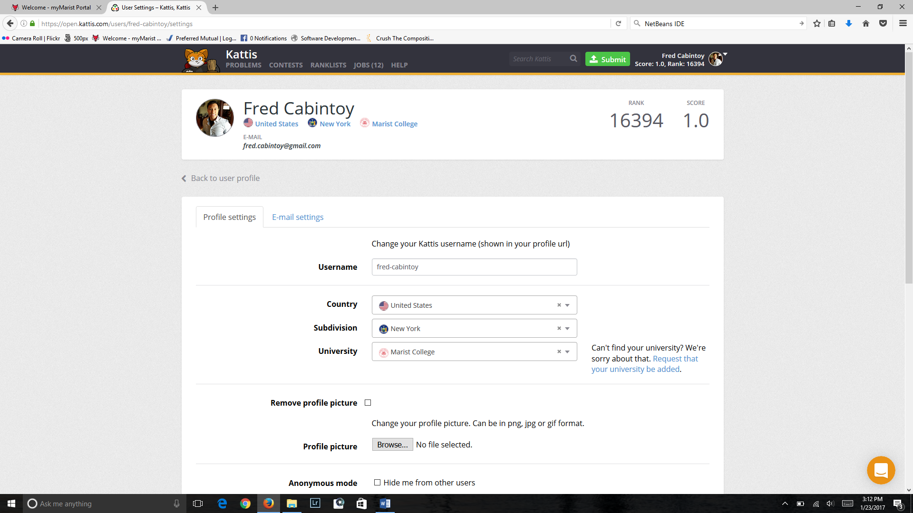

Github Account / Class Repository / HTTPS link

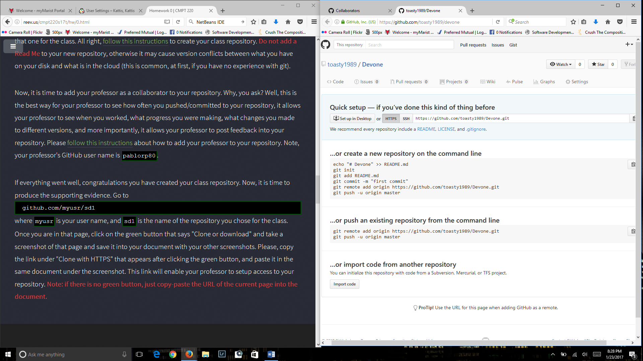

Github Repository: <https://github.com/toasty1989/devone>

It’s not a selfie but it’s a child portrait of me that no-one else would have.

